Kwame Brathwaite

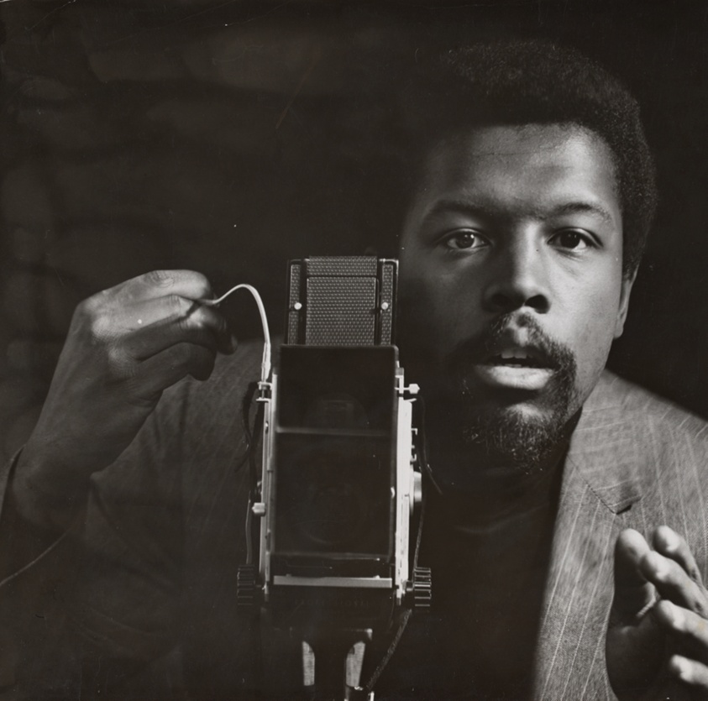Figure Untitled (Self-Portrait Taken in AJAS Studio), about 1964

Untitled (Self-Portrait Taken in AJAS Studio)

## Date:

c. 1964

## Artist:

Kwame Brathwaite  
American, born 1938

<https://www.artic.edu/artworks/260587/untitled-self-portrait-taken-in-ajas-studio>

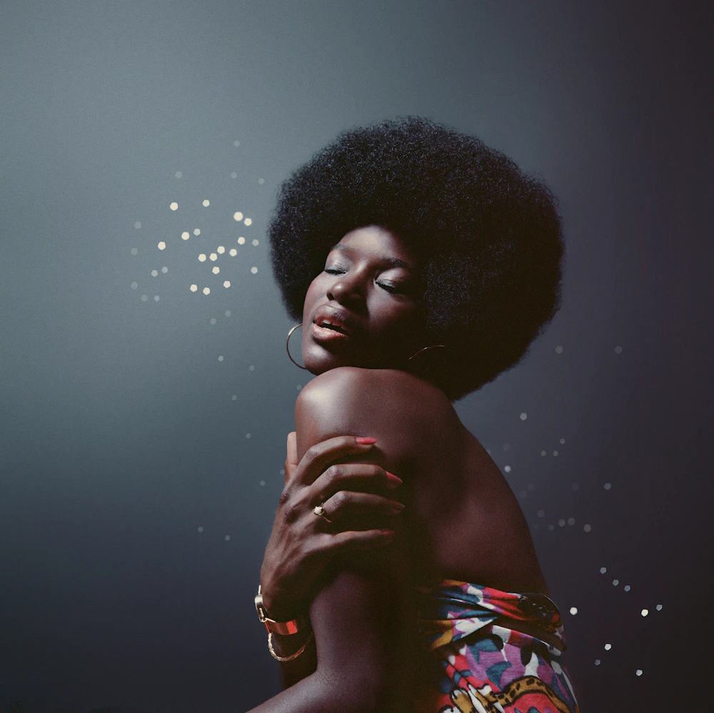

Figure Changing Times, about 1973, printed 2021

Changing Times, about 1973, printed 2021

Kwame Brathwaite. The Kwame Brathwaite Archive and Philip Martin Gallery. © The Kwame Brathwaite Archive



Figure Untitled (Stevie Wonder Headlines Human Kindness Day at the National Mall, Washington, DC), 1975

Untitled (Stevie Wonder Headlines Human Kindness Day at the National Mall, Washington, DC), 1975

Kwame Brathwaite. The Kwame Brathwaite Archive and Philip Martin Gallery. © The Kwame Brathwaite Archive

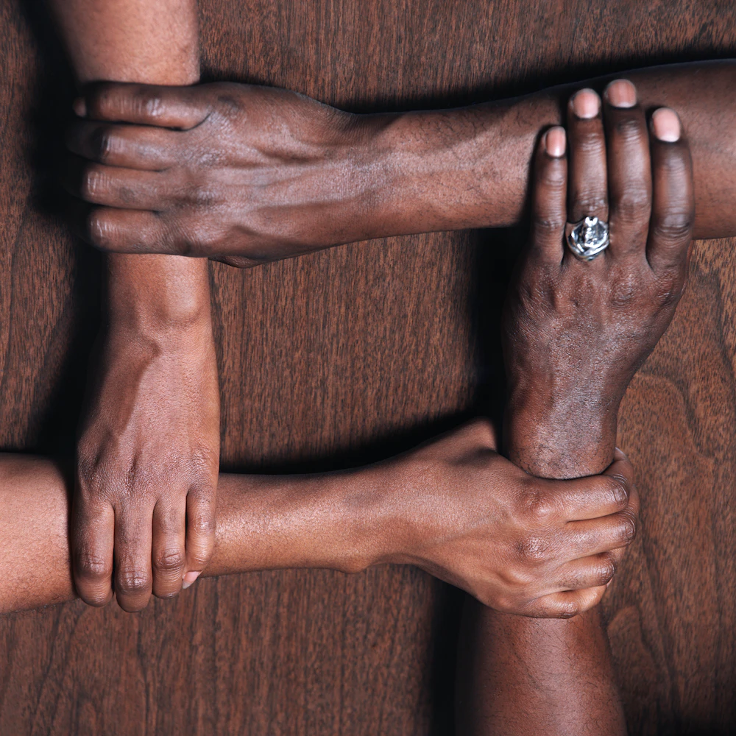

Figure Untitled (Hands in the Shape of a Unity Symbol), about 1971, printed 2021

Untitled (Hands in the Shape of a Unity Symbol), about 1971, printed 2021

Kwame Brathwaite. The Kwame Brathwaite Archive and Philip Martin Gallery. © The Kwame Brathwaite Archive

Salvador Dali

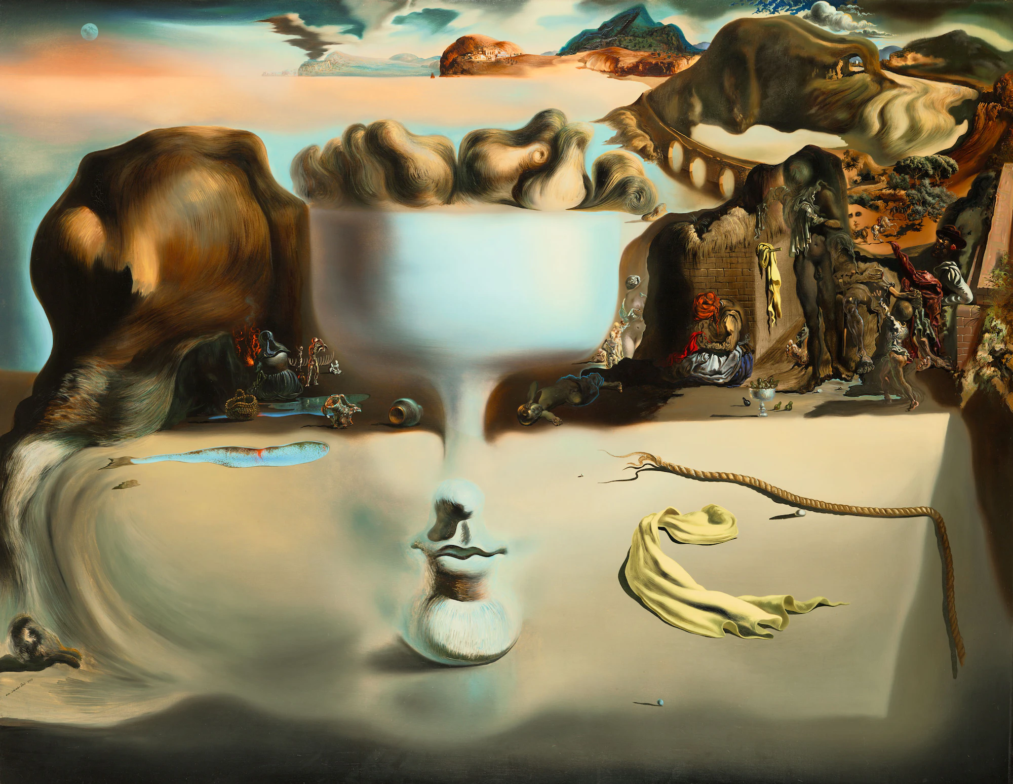

Figure Apparition of Face and Fruit Dish on a Beach, 1938

*Apparition of Face and Fruit Dish on a Beach*, 1938

Salvador Dalí. Wadsworth Atheneum Museum of Art, Hartford, Connecticut. © Salvador Dalí, Fundació Gala-Salvador Dalí / Artists Rights Society (ARS), New York, 2022

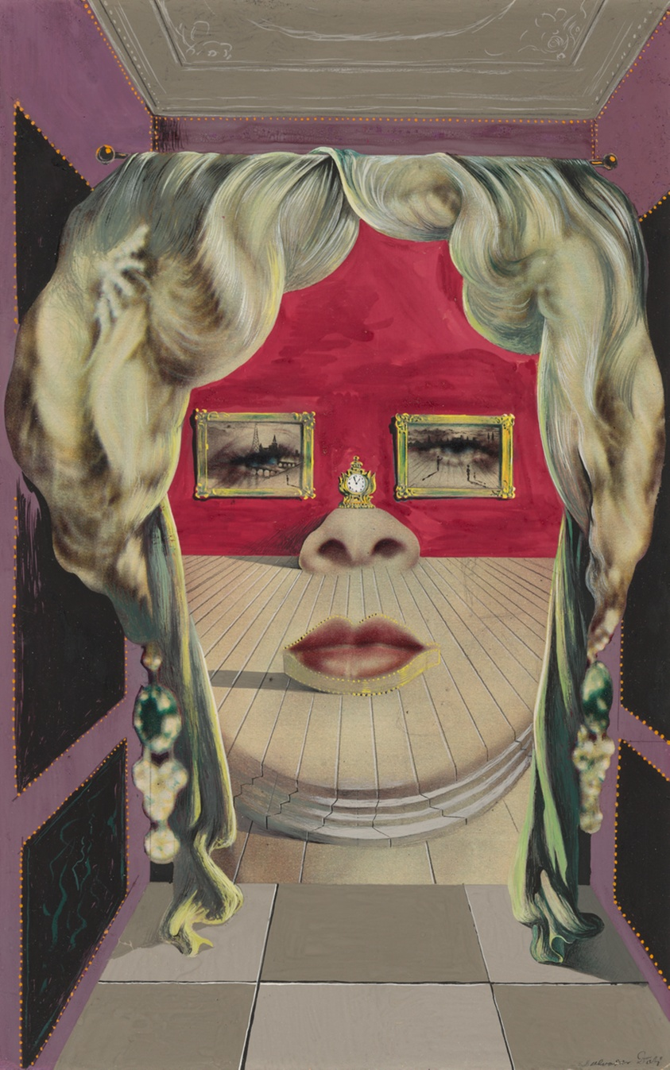

Figure A Chemist Lifting with Extreme Precaution the Cuticle of a Grand Piano

Mae West’s Face which May be Used as a Surrealist Apartment

© Salvador Dalí, Fundació Gala-Salvador Dalí / Artists Rights Society (ARS), New York, 2018

<https://www.artic.edu/artworks/65819/mae-west-s-face-which-may-be-used-as-a-surrealist-apartment>

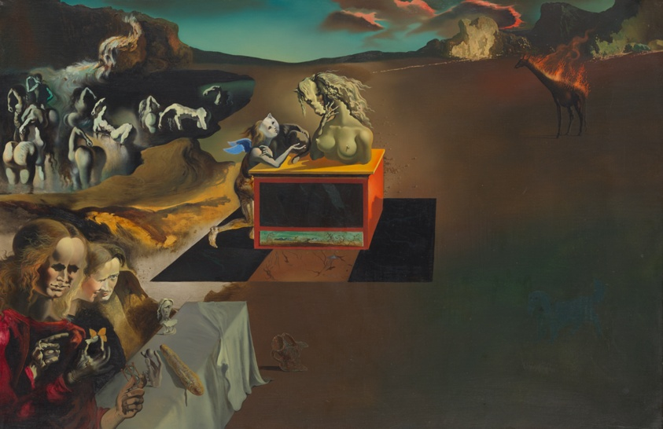

Figure Inventions of the Monsters, 1937

Inventions of the Monsters

**Date:**

1937

© Salvador Dalí, Fundació Gala-Salvador Dalí / Artists Rights Society (ARS), New York, 2018

https://www.artic.edu/artworks/151424/inventions-of-the-monsters

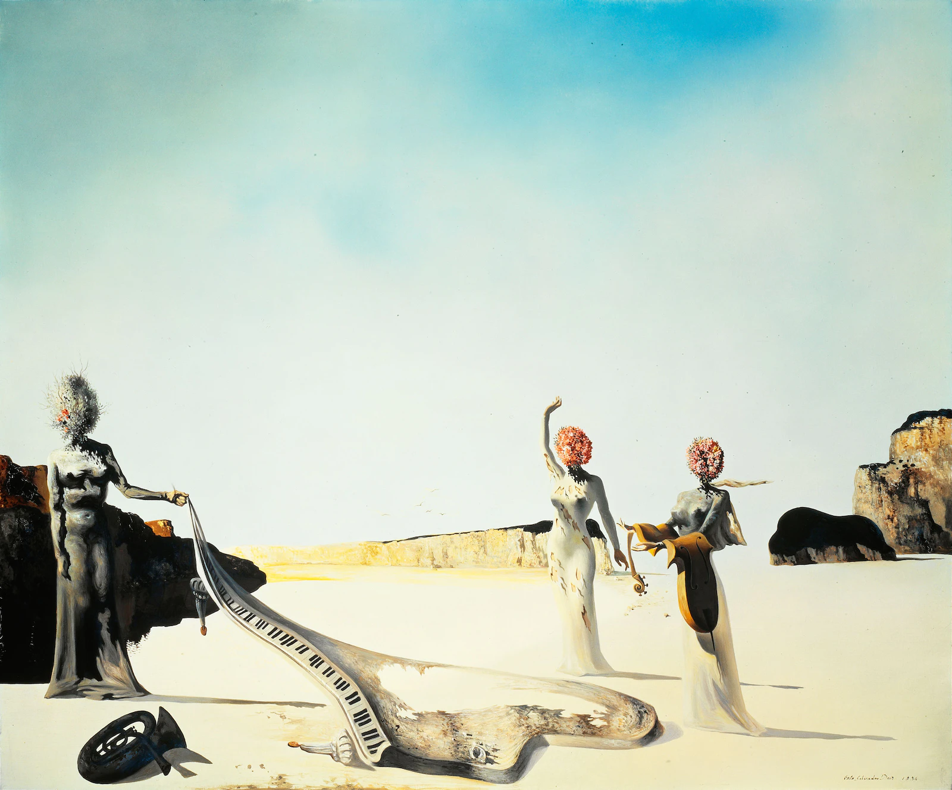

Figure Three Young Surrealist Women Holding in Their Arms the Skins of an Orchestra, 1936

Three Young Surrealist Women Holding in Their Arms the Skins of an Orchestra, 1936

Salvador Dalí. The Dalí Museum, St. Petersburg, Florida. © Salvador Dalí, Fundació Gala-Salvador Dalí, Figueres, 2007 USA: © Salvador Dalí Museum Inc., St. Petersburg, FL, 2007

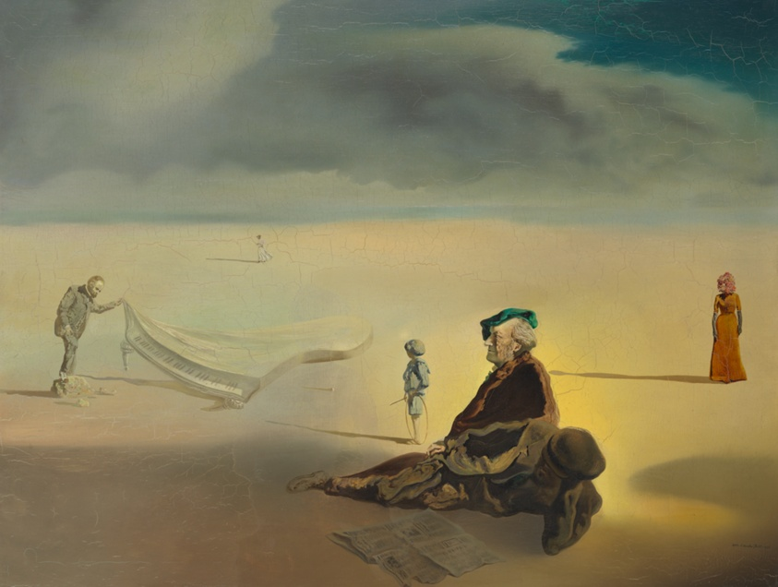

Figure A Chemist Lifting with Extreme Precaution the Cuticle of a Grand Piano

A Chemist Lifting with Extreme Precaution the Cuticle of a Grand Piano

© Salvador Dalí, Fundació Gala-Salvador Dalí / Artists Rights Society (ARS), New York, 2018

<https://www.artic.edu/artworks/145241/a-chemist-lifting-with-extreme-precaution-the-cuticle-of-a-grand-piano>

Ancient Egypt

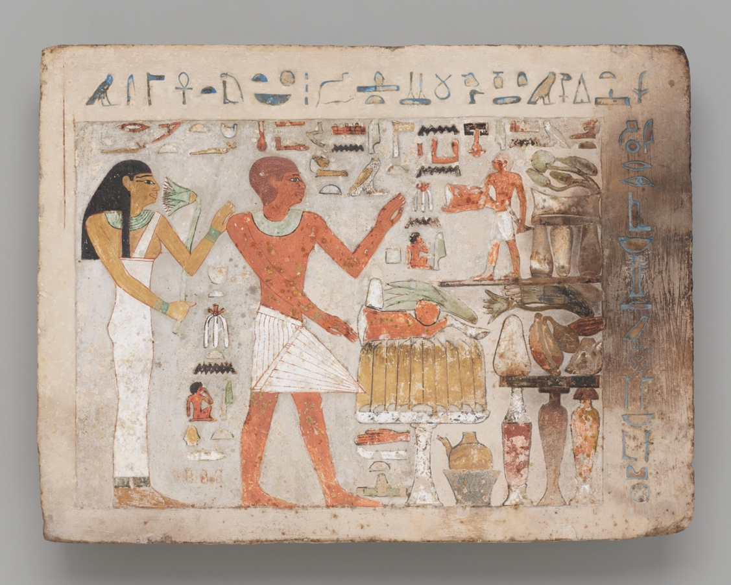

Figure 10Stela of Amenemhat and Hemet, Middle Kingdom, early Dynasty 12, about 1956–1877 BCE

Stela of Amenemhat and Hemet

## Date:

Middle Kingdom, early Dynasty 12, about 1956–1877 BCE

## Artist:

Egyptian; probably Thebes (now Luxor), Egypt

https://www.artic.edu/artworks/127859/stela-of-amenemhat-and-hemet

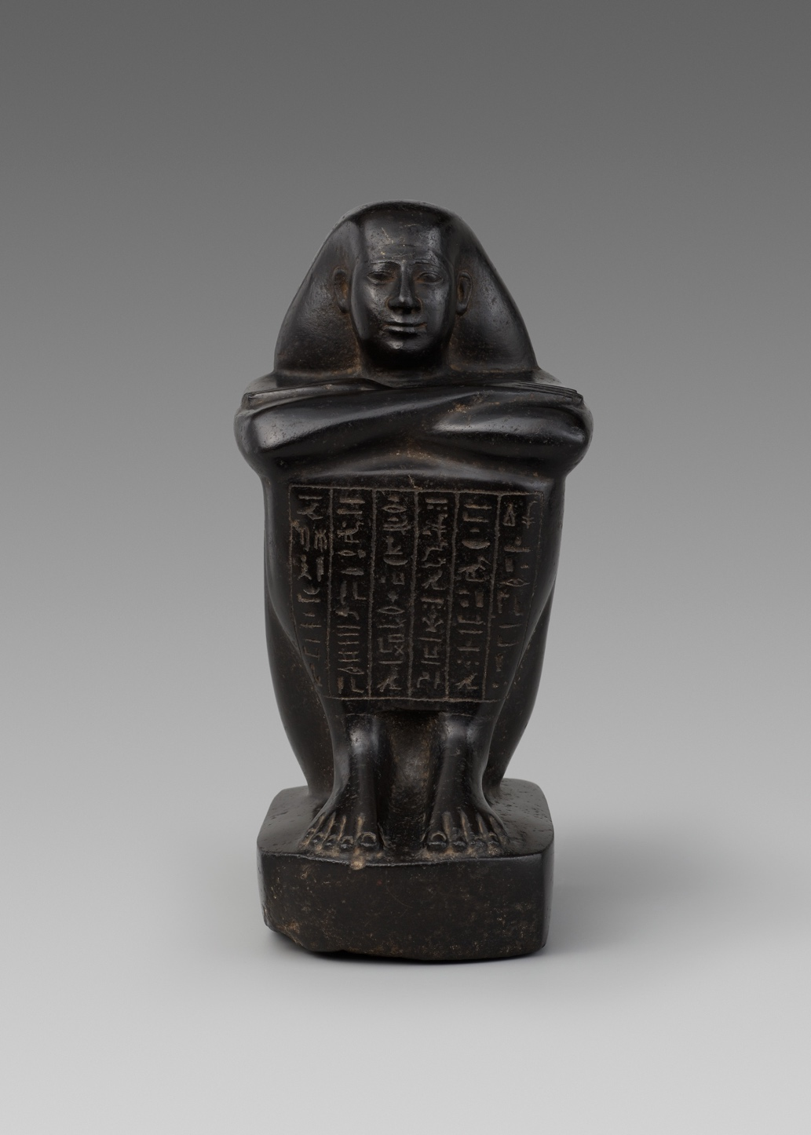

Figure 11Statue of Shebenhor, Late Period, Dynasty 26 (664-525 BCE

Statue of Shebenhor

## Date:

Late Period, Dynasty 26 (664-525 BCE)

## Artist:

Egyptian; Memphis, Egypt

<https://www.artic.edu/artworks/13454/statue-of-shebenhor>

)

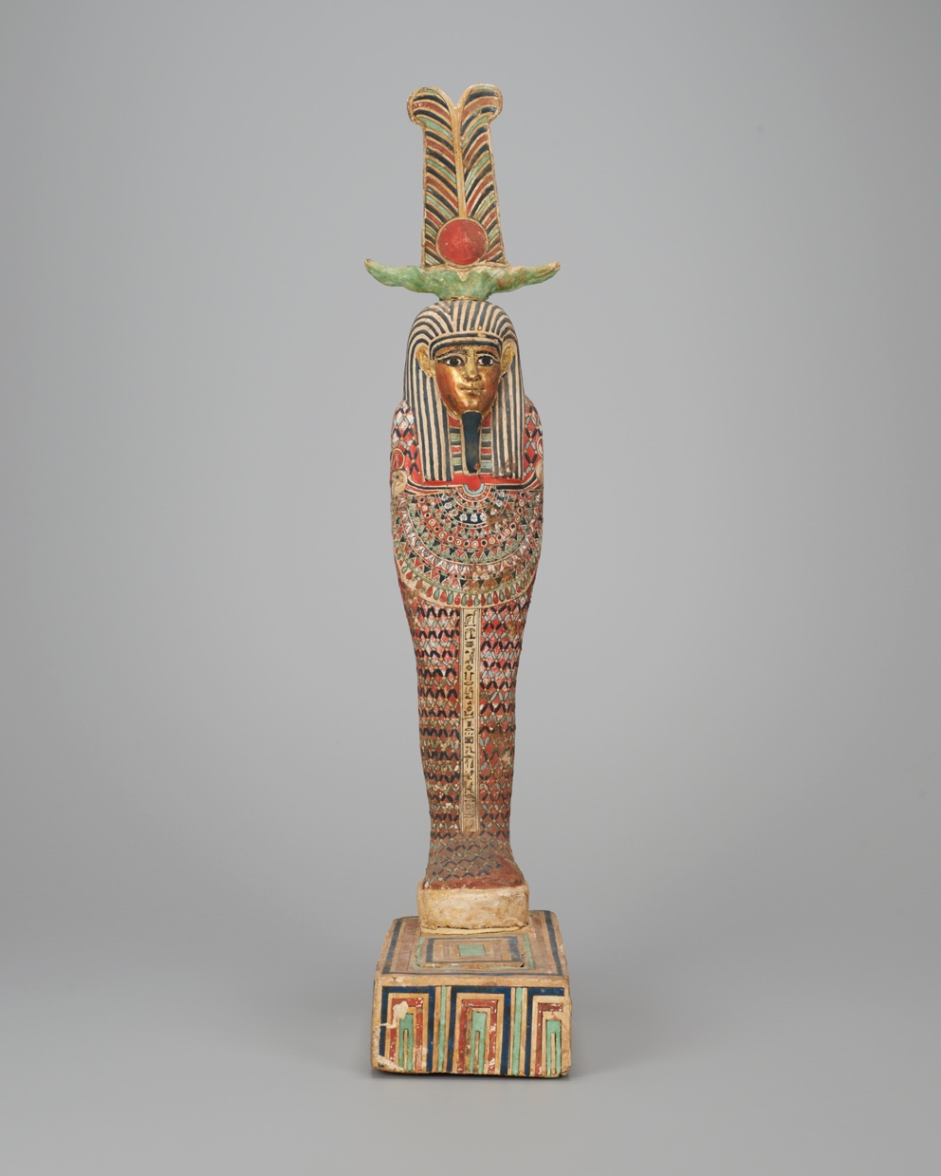

Figure Statue of Ptah-Sokar-Osiris, Ptolemaic Period (332–30 BCE)

Statue of Ptah-Sokar-Osiris

## Date:

Ptolemaic Period (332–30 BCE)

## Artist:

Egyptian

<https://www.artic.edu/artworks/160171/statue-of-ptah-sokar-osiris>

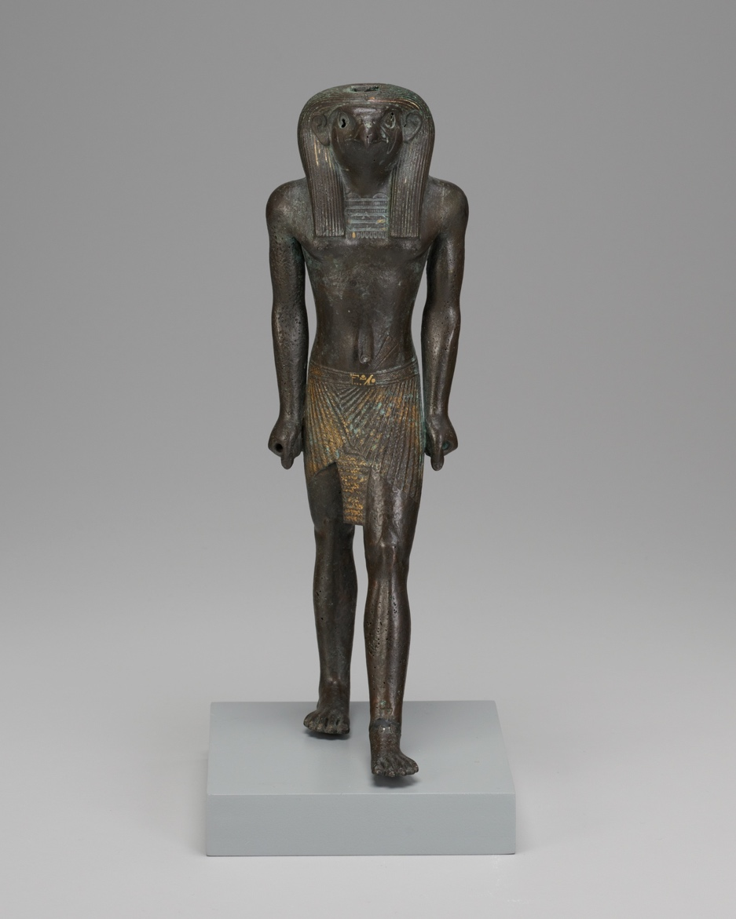

Figure Statuette of Re-Horakhty, Third Intermediate Period-Late Period, Dynasty 21–26, about 1069–525 BCE

Statuette of Re-Horakhty

## Date:

Third Intermediate Period-Late Period, Dynasty 21–26, about 1069–525 BCE

## Artist:

Egyptian

<https://www.artic.edu/artworks/120300/statuette-of-re-horakhty>